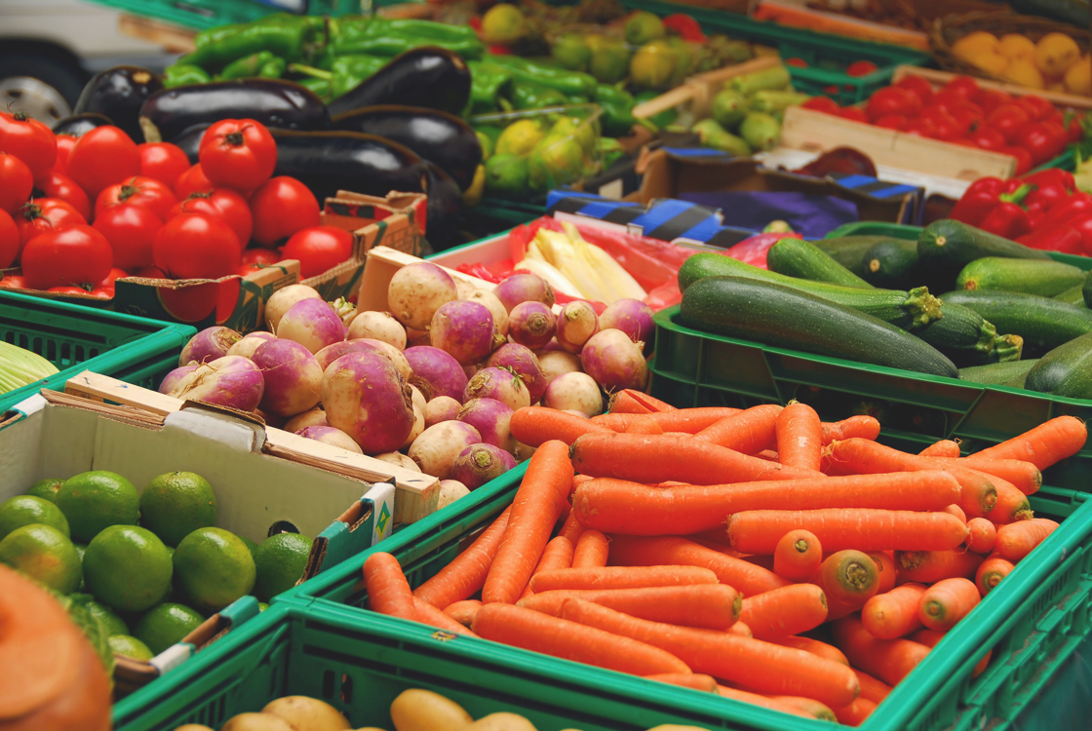

Moore County Farmers Market

Mondays First Health (Fitness Center)
170 Memorial Drive, Pinehurst, NC 28374
2:00pm-5:30pm ~ April 15- October 28
Facility Courtesy of FirstHealth

Thursdays
Morganton Rd (Armory Sports Complex)
Southern Pines, NC 28387
9:00am-1:00pm ~ Year Round
Facility Courtesy of Town of Southern Pines

Saturdays
Downtown Southern Pines
SE Broad & NY Ave., Southern Pines, NC 28388
8:00am -noon ~ April 20- October 26
No market Oct. 5- due to Autumnfest
Facility Courtesy of Town of Southern Pines

Questions? Contact Mkt. Mgr. Harry Webster
hwwebster@embarqmail.com
910-947-3752; 910-690-9520
Web Search: Moore County Farmers Market Local Harvest

Sandhills Farmers Green Market

Wednesdays
Cannon Park
(corner of Rattlesnake Trail/Woods Rd
off Hwy 211W near traffic circle)
3:00pm-6:00pm ~ begins April 10
Facility Courtesy of Village of Pinehurst

Saturdays
Homegrown on the Village Green
In the sandlot on the Pinehurst Village Green
(1 Village Green Rd. West Pinehurst, NC)
10:00am-1:00pm~ begins May 4
Facility Courtesy of Village of Pinehurst

Questions? Contact Melanie Riley
803-517-5476
http:/sandhillsfarmersmarket.com
http://www.localharvest.org/sandhills-farmers-green-market-M45243



