Moore County Master Gardener Class

Fall 2017 Syllabus

9:00 a.m. - 12 noon, Tuesdays and Thursdays, except as **noted**

Date Topic <https://content.ces.ncsu.edu/extension-gardener-handbook>

Oct. 3 Orientation, Botany 3 <https://content.ces.ncsu.edu/extension-gardener-handbook/3-botany>

5 Plant Physiology 3 <https://content.ces.ncsu.edu/extension-gardener-handbook/3-botany#section_heading_6937>

10 Soils & Cover Crops 1 <https://content.ces.ncsu.edu/extension-gardener-handbook/1-soils-and-plant-nutrients>

& Moore Soil Survey <https://www.nrcs.usda.gov/Internet/FSE_MANUSCRIPTS/north_carolina/mooreNC1995/text.pdf>

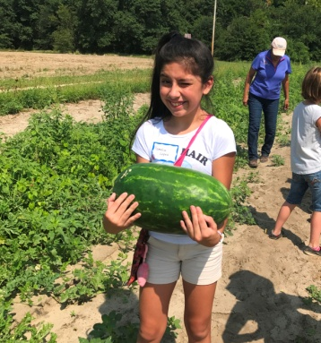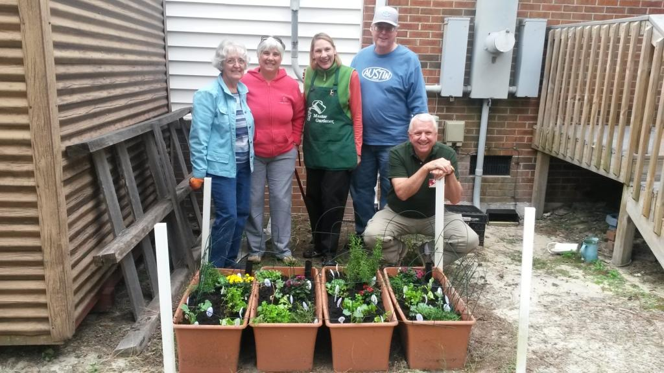

12 Soils & Fertility II 1 & Soil Survey

17 Composting & Cover Crops 2 <https://content.ces.ncsu.edu/extension-gardener-handbook/2-composting>

19 Sustainable Fruit Production 14 <https://content.ces.ncsu.edu/extension-gardener-handbook/14-small-fruits>

15 <https://content.ces.ncsu.edu/extension-gardener-handbook/15-tree-fruit-and-nuts>

**Field Trip-SRS!!!**

24 Sustainable Insect Mgt. 4 <https://content.ces.ncsu.edu/extension-gardener-handbook/4-insects>

26 Pruning, Propagation 13 <https://content.ces.ncsu.edu/extension-gardener-handbook/13-propagation>

11 <https://content.ces.ncsu.edu/extension-gardener-handbook/11-woody-ornamentals>

31 Sustainable Lawn Care 9 <https://content.ces.ncsu.edu/extension-gardener-handbook/9-lawns>

Nov. 2 Sustainable Floriculture 10 <https://content.ces.ncsu.edu/extension-gardener-handbook/10-herbaceous-ornamentals> **Field Trip!!!**

7 Gardening with youth 21 <https://content.ces.ncsu.edu/extension-gardener-handbook/21-youth-community-and-therapeutic-gardening>

**Field trip!** Food Corps

9 Plant Diseases 5 <https://content.ces.ncsu.edu/extension-gardener-handbook/5-diseases-and-disorders>

14 Pest Management Resources <http://content.ces.ncsu.edu/north-carolina-agricultural-chemicals-manual>

App B. <https://content.ces.ncsu.edu/extension-gardener-handbook/appendix-b-pesticide-safety>

16 Xeriscaping, Woody Plants 19 <https://content.ces.ncsu.edu/extension-gardener-handbook/19-landscape-design>

21 Sustainable Vegetables 16 <https://content.ces.ncsu.edu/extension-gardener-handbook/16-vegetable-gardening>

& Final Exam (Take Home)

28 Weeds & Wildlife 6 <https://content.ces.ncsu.edu/extension-gardener-handbook/6-weeds>

20 <https://content.ces.ncsu.edu/extension-gardener-handbook/20-wildlife>

<https://gardening.ces.ncsu.edu/wildlife/>

(Exam Due)

30 Graduation Party!!! **Location Senior Enrichment Center**

